Name:________________
Period:____
Gideon v. Wainwright (1963)
"If an obscure Florida convict named Clarence Earl Gideon had not sat down in his prison cell . . . to write a letter to the Supreme Court . . . the vast machinery of American law would have gone on functioning undisturbed. But Gideon did write that letter, the Court did look into his case . . . and the whole course of American legal history has been changed."
—Robert F. Kennedy

1. Why was Clarence Earl Gideon incarcerated?

2. In your opinion how well did Gideon defend himself? Why?

3. What could a lawyer have done differently? Would that have changed the outcome of the case?

- Can the average person, who like Gideon, is not illiterate or incompetent, do an adequate job of defending himself or herself at trial? Why or why not?

- What previous Supreme Court decision did Gideon’s case try to overturn? What did that previous decision say and what was Gideon’s argument?

- Explain the following terms/rules that Gideon must follow before submitting the case to the Supreme Court
  - Writ of habeas corpus:

  - Writ of certiorari:

  - In forma pauperis:

  - Rule of 4

- Analyze the round table meeting of the Supreme Court justices. What do you think about these two points:
  - When do a man’s right to counsel begin?

  - What is a problem with the practical application of a potential

- List how the following amendments were involved in the case:

  - 5th Amendment: No person shall be held to answer for a capital, or otherwise infamous crime, unless on presentment or indictment of a Grand Jury, except in cases arising in the land or naval forces, or in the Militia, when in actual service in time of War or public danger; nor shall any person be subject for the same offense to be twice put in jeopardy of life or limb; nor shall be compelled in any criminal case to be a witness against himself, nor be deprived of life, liberty, or property, without due process of law; nor shall private property be taken for public use, without just compensation.

  - 6th Amendment: In all criminal prosecutions, the accused shall enjoy the right to a speedy and public trial, by an impartial jury of the State and district where in the crime shall have been committed, which district shall have been previously ascertained by law, and to be informed of the nature and cause of the accusation; to be confronted with the witnesses against him; to have compulsory process for obtaining witnesses in his favor, and to have the Assistance of Counsel for his defence

  - 14th Amendment: Section 1. All persons born or naturalized in the United States, and subject to the jurisdiction thereof, are citizens of the United States and of the State wherein they reside. No State shall make or enforce any law which shall abridge the privileges or immunities of citizens of the United States; nor shall any State deprive any person of life, liberty, or property, without due process of law; nor deny to any person within its jurisdiction the equal protection of the laws.

- What was the final outcome of the Gideon case? What were its effects on the American judicial system?

Analyze the Political Cartoon Below: In 2008, The New York Times reported that public defenders' offices around the country were so swamped with cases that they were refusing to take new clients, asserting that if they did so, their clients would not be able to receive the time or attention necessary for competent counsel.
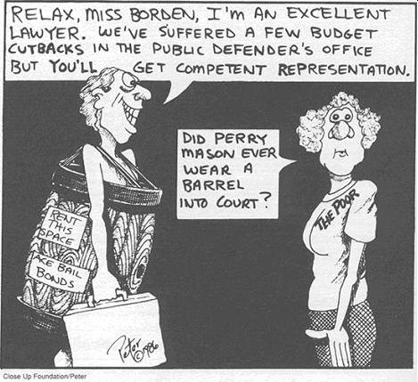
10. What is the cartoonist's message? Does he or she think that the decision in Gideon v. Wainwright has resulted in fair representation for poor defendants? Do you agree or disagree with the message? Explain your answer.

