Turkish PM says he won't apologize to Armenians

By SELCAN HACAOGLU – 23 hours ago,

ANKARA, Turkey (AP) — Turkey's prime minister on Wednesday said he will not join a group of Turkish intellectuals who issued an apology on the Internet for the World War I-era massacres of Armenians in Turkey.

"If there is a crime, then those who committed it can offer an apology. My nation, my country has no such issue," Recep Tayyip Erdogan said. "I personally do not support this campaign."

The Turkish prime minister's reaction, echoed by nationalists and even members of opposition parties, was a setback for the intellectuals' hopes to nurture reconciliation by shattering a taboo against acknowledging Turkish culpability for the deaths.

Several Turkish diplomats and lawmakers have condemned the apology and hundreds of Turks joined groups that popped up on Facebook with titles such as "I am not apologizing."

Erdogan said the apology issued Monday threatens to damage improved relations and is not binding.

"This initiative jeopardizes Turkey's Armenia policy because it could trigger public pressure and polarization within Turkey," Erdal Safak, a columnist for daily Sabah newspaper, wrote in Wednesday editions.

Armenia and Turkey do not have diplomatic relations because of the dispute over the killings of Armenians during World War I, which Armenians claim was genocide. Their shared border has been closed since 1993, when Turkey protested Armenia's occupation of Nagorno-Karabakh. Turkey backs Azerbaijan's claims to the disputed region, which has a high number of ethnic Armenian residents but is located within Azerbaijan's borders.

Historians estimate up to 1.5 million Armenians were killed by Ottoman Turks around the time of World War I, an event widely viewed by genocide scholars as the first genocide of the 20th century. Turkey, however, denies the deaths constituted genocide, saying that the toll has been inflated and that those killed were victims of civil war and unrest.
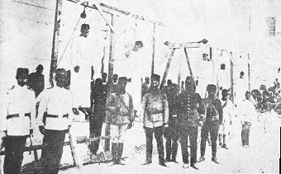
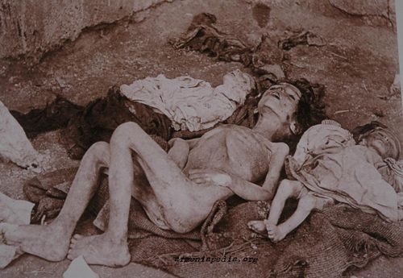
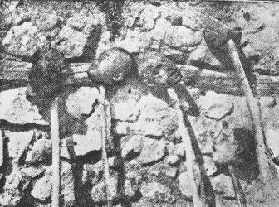
hFor more info See: http://www.umd.umich.edu/dept/armenian/facts/genocide.html
For Extra Credit: Redo page 410 of our textbook in indesign and make the Armenian Genocide “History in Depth” really in depth. Include more details, pictures, and the modern ramifications of this genocide on today’s politics.

