1. Read the following extract from ‘German Deserter’s War Experience’ then list words to describe what it was like to be in a trench in World War One.
It was dark, and it rained and rained. From all directions one heard in the darkness the wounded calling, crying, and moaning. The wounded we had with us were likewise moaning and crying. All wanted to have their wounds dressed, but we had no more bandages. We tore off pieces of our dirty shirts and placed the rags on those sickening wounds. Men were dying one after the other. There were no doctors, no bandages; we had nothing whatever. You had to help the wounded and keep the French off at the same time. It was an unbearable, impossible state of things. It rained harder and harder. We were wet to our skins. We fired blindly into the darkness. The rolling fire of rifles increased, then died away, then increased again. We sappers were placed among the infantry. My neighbour gave me a dig in the ribs."

2. Look at diagram A. Examine it and answer the following questions. See http://www.historyonthenet.com/WW1/trenches.htm for a close-up picture.
- What links the front line and support trenches?
- Why are blocks placed in trenches?
- Why are machine-guns placed just behind the front line? Why are they so close to the bunkers?
- Why is there wire between the front trench and the machine-guns?
- Look at the barbed wire in No-Man's Land that is at angles to the front trench and also look at the position of the machine-guns. Why is the wire at such an angle?

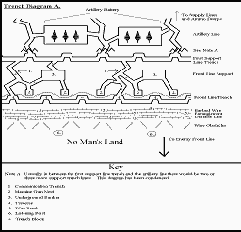
3.
- What prevents bullets striking a soldier's chest when he is on the trench board (fire step)?
- What is the purpose of the sump? What was normally placed over it?
- Barbed wire entanglements were often 40 yards (36m) from the front trench. Considering the types of weapons used on the Western Front, what would be their main defensive function?

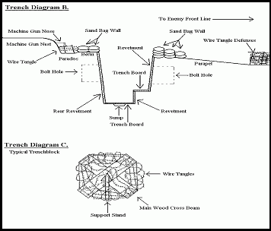

Some soldiers left records of how they felt about and reacted to trench warfare.
Look at the seven descriptions of aspects of battle from Australian soldiers who experienced it. In the margins explain what the document is telling us about the nature of battle, what personal qualities the writer shows, and what the reader’s reaction is to that extract — for example you might be proud of the bravery of the person, or shocked at the pain that is described, or ashamed of the brutality that might be shown. After all the documents, complete this sentence: ‘These extracts tell me that ...’

Source A
I can’t sleep now because –
Six shells are bursting around here every minute
Guns are belching out shells, with a thunderous sound each time
The ground is shaking with each explosion
I am wet and the ground on which I rest is wet
My feet are cold, in fact I’m all cold with my two skimpy blankets
I am covered with dirt
I am hungry
I see no chance for a better tomorrow
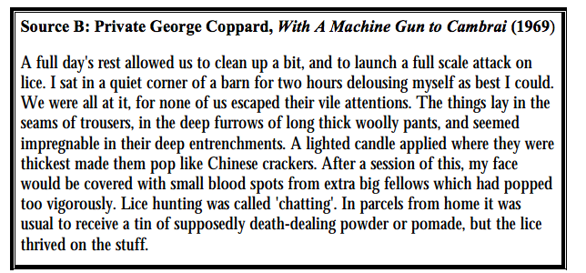.

Source C
One of our officers got shell shock under all the shelling and he cried like a child. Some were calling out for their mother.

Source D
The mud was so bad that last time we were here one of our officers rode into a shell hole and he disappeared. He had to be pulled out by ropes.

Source E
I am on my way to hospital suffering trench feet due to being up to my knees in water for 72 hours.

Source F
The country around here is very much knocked about by Artillery and shell holes are the worry of our lives – one cannot walk 10 metres in the dark without tumbling into one. Barbed wire entanglements are scattered about, and at night we have to keep our eyes open, otherwise we get caught in it ... Grave yards are everywhere and no matter where one looks he sees little white crosses.

Source G
24/8/16
Dearest Beat and Bill,
Just a line … you must be prepared for the worst to happen any day. It is no use trying to hide things. I am in terrible agony…Tomorrow I shall know the worst as the dressing [on his wounded leg] was to be left for 3 days and tomorrow is the third day it smells rotten. I was hit running out to see the other officer who was with me but badly wounded … I got two machine gun bullets in the thigh… The Stretcher Bearers could not get the wounded out any way other than over the top and across the open. They had to carry me four miles with a man waving a red cross flag in front and the Germans did not open fire on us. Well dearest I have had a rest, the pain is getting worse and worse … So cheer up dear I could write on a lot but I am nearly unconscious. Give my love to Dear Bill and yourself, do take care of yourself and him.
Your loving husband
Bert (Lieutenant HW Crowle died a few hours after writing this letter.)
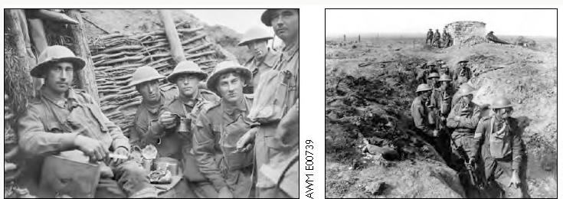
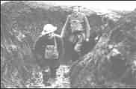
The trench, when we reached it, was half full of mud and water. We set to work to try and drain it. Our efforts were hampered by the fact that the French, who had first occupied it, had buried their dead in the bottom and sides. Every stroke of the pick encountered a body. The smell was awful. Private Pollard

No washing or shaving here, and the demands of nature answered as quickly as possible in the handiest and deepest shell-hole. Guy Chapman
The stench of the dead bodies now is awful as they have been exposed to the sun for several days, many have swollen and burst. The trench is full of other occupants, things with lots of legs, also swarms of rats. Sergeant A Vine

The other one said to me "Chas, I am going home to my wife and kids. I'll be some use to them as a cripple, but none at all dead! I am starving here, and so are they at home, we may as well starve together." With that he fired a shot through his boot. When the medics got his boot off, two of his toes and a lot of his foot had gone. But the injuring oneself to get out of it was quite common. Charles Young

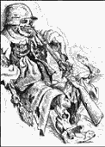
All we lived on was tea and dog biscuits. If we got meat once a week we were lucky, but imagine trying to eat standing in a trench full of water with the smell of dead bodies nearby. Richard Beasley
The other soldiers in the hut took their shirts off after tea. They were catching lice. We had never seen a louse before, but they were here in droves. The men were killing them between their nails. Henry Gregory
If you have never had trench feet described to you. I will tell you. Your feet swell to two or three times their normal size and go completely dead. You could stick a bayonet into them and not feel a thing. If you are fortunate enough not to lose your feet and the swelling begins to go down. It is then that the intolerable, indescribable agony begins. I have heard men cry and even scream with the pain and many had to have their feet and legs amputated. Sergeant Harry Roberts

Activity

Imagine that you are a soldier fighting in the trenches. Write a letter home describing the conditions in the trenches.
These feet have trench foot and frostbite caused by standing for hours in a freezing waterlogged trench. To avoid this condition soldiers were told to change their socks regularly, wear waterproof footwear or gumboots and cover their feet with whale oil.
