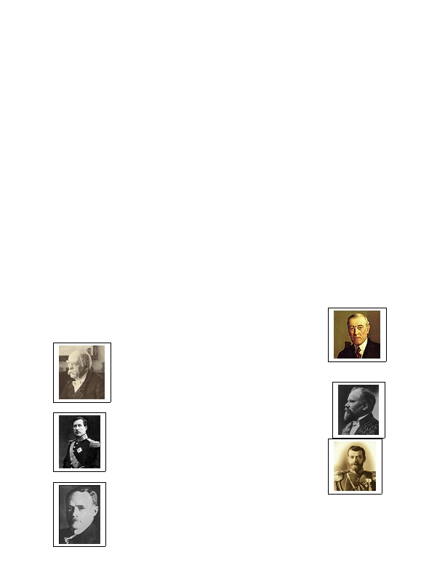
TRIAL OF KAISER WILHELM II

OBJECTIVE: To determine whether or not Kaiser Wilhelm II was primarily responsible for the outbreak and escalation of the First World War through a trial procedure. The trial will be held in he newly created World Court of the League of Nations on March 28, 1920.

The students will be chosen by the teacher to play the following roles.
Court Officials:

Judge - expected to follow American type judicial system features and keep order in the court.
Bailiff - Follows the judges bidding to maintain order in the court and to swear in witnesses.

Defense Lawyers - Will be composed of a Lead Attorney who will complete the opening and closing statements and lead questioning of chosen witnesses. The second attorney who will lead questioning of other witnesses, and the paralegal who must help the lawyers research the case and conduct cross examination of one witness.

Prosecution Attorneys - Will be composed of a Lead Attorney who will complete the opening and closing statements and lead questioning of chosen witnesses. The second attorney who will lead questioning of other witnesses, and the paralegal who must help the lawyers research the case and conduct cross examination of one witness.

Court Reporter - Will be responsible for taking down the questions and the gist of the answers as the trial proceeds. Can you say hand cramp? The teacher will collect the brief at the end of the trial.

Accused:
Kaiser Wilhelm II - leader of the German Empire at the start of the war. Obviously you willl want to prove that other nations were the cause of the conflict

Witnesses:
Prosecution: These witnesses may or may not like Wilhelm, but should be used to help damn him (get a guilty verdict).

1.) Woodrow Wilson - president of the United States during the war. Angry at the Germans because of
unrestricted submarine warfare and Zimmerman Telegramm. Believes Wilhelm the cause of the war and its
escalation

2.) Otto Von Bismarck- long time chancellor of Prussia who united Germany…
some say he broke down the balance of power in Europe while others credit him with
setting up a stable alliance system in Europe. He was angered that Wilhelm broke down
this system by creating a naval race and not resigning the Reinsurance Treaty.

3.) Raymond Poincaré - President of France at the time of the war's outbreak, also
knew the dealings of the French Premier, Viviani.

4.) King Albert - King of Belgium and a witness to the destruction
of its cities. Famously stated, ""Belgium is a nation, not a road."

5.) Tsar Nicholas II (Romanov) - "Tsar of all the Russias" at the start of World War I.
Also knew Kaiser personally as they were cousins . They wrote to each other often.
6.) Gustav Krupp owned a "city within a city" which produced weapons in Germany. You are key to demonstrating Germany!s militaristic nature at the time, yet you don’t want Wilhelm prosecuted/found guilty.
7.) Sir Edward Grey - key official in the United Kingdom at the start of the war. Pushed the cabinet to go to war after the German invasion of Belgium but earlier made many peace deals. Some will question how you failed to warn the Germans of how serious England was over the Belgium issue but you truly wanted peace.
Defense: These witnesses will be called first by the defense and cross- examined by the prosecution. Note: Just because they are called by the defense doesn't mean that they would personally like to help the defenses’ case.

1.) Count Leopold von Berchtold - Austrian foreign minister at war's
outbreak, representative of the court for the now dead Franz Joseph II,
emperor of Austria.

2.) Theobald von Bethman-Hollweg - Chancellor of Germany at
the start of World War I .

3.) Gavrilo Princip - as a member of the "Black Hand" he
assassinated and killed Archduke Franz Ferdinand of
Austria.

4.) Sergei Sazanov - Russian foreign minister at the war's
outbreak. Desired war with Austria for years, but hesitated as conflict
neared

5.) Franz Conrad von Hötzendorf - Head of the Austrian
military machine who desired war with Italy and other
nations in order to secure Austria's Great Power status.
Written Assignment:

International Tribunal Members (jury) - Members of this international body and its assigned foreman must write a two - three page typed position paper based on their experiences during the trial. The main focus of your paper should be why you felt Kaiser Wilhelm was
innocent or guilty.

Attorneys and paralegals - You must turn in your research notes you took while examining the evidence along with a written introduction ( one page) mentioning the strategy you developed for your case.

Witnesses- Must dress their part for the trial and complete a bibliographic paper on your subject (person). Make sure you focus on what role your character played in the condemnation or savior of Wilhelm in the trial and in reality.

Judge/Bailiff - You must write a position paper examining whether or not the trial verdict was justified.

* All Papers must be typed!
